 | GOVERNMENT OF INDIA  MINISTRY OF RAILWAYS  RAILWAY RECRUITMENT CELLS | 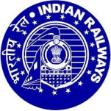

NOTICE FOR MOCK LINK FOR CBT OF CENTRALISED GDCE-2023

Candidates of GDCE-2023 are hereby informed that they can familiarize with interface for taking Computer Based Test (CBT).
The link is – rrcgdce2023.cbtexam.in
The aforesaid link will be active from 22.00 hours of 30.11.2023.
Candidates are advised to get familiarize for the same.

Dated : 30.11.2023 Sd/- Dy. Chief Personnel Officer
East Coast Railway

